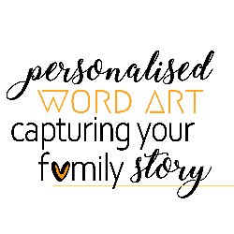
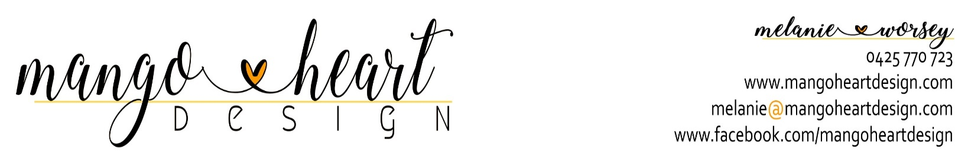

order form
Details of person ordering design:
Name –
Email Address –
Contact Number –
Address –
Where did you hear about my designs?(Viewed someone else's - who? Facebook? Google? Market - which one? Some other way?) –
Frames, delivery and postage options incur additional cost.
Quoted times for completion conditioned on levels of communication, printing availability, individual requirements and personal circumstances.
Colours may vary slightly from those shown. Differences may be due to screen settings, paper specifications and printing variabilities.

Information for design:
Shape (heart/square/ rectangle – long or tall) –
Background colour (black/blue/red/tan/charcoal) –
Edge (even or uneven if square or rectangular chosen) –
Text colour (all white/black and white/pastel highlights) –
Size (16 x 16 in/20 x 20 in/24 x 24 in) –
Printed product (high quality bonded paper/high quality stretched canvas*) –
*please note canvas products can take up to 3 weeks to be printed once final approval on image is received.
Frame and matting colours (white, black and dark brown frames with white or black matting) –
*framing incurs additional costs, please check pricing details.

Design Overview : Let me know a general idea of what is this design celebrating? e.g. wedding, anniversary, birthday, family, thankyou gift etc. Is it about an individual or a family/families? Is the family name to be the central focus across the middle or an individual name or a quote? Any other general information you'd like me to know? –
Family Name –

Female:
First name –
Nickname (or other affectionate description/endearment) –
Date of Birth –
Male:
First Name –
Nickname (or other affectionate description/endearment) –
Date of Birth –

Marriage Date/Special Date –
Place of Marriage (or other important place name) –

Children:
Child 1
Name –
Nickname (or other affectionate description/endearment) –
Date of Birth –
Spouse/Partners name –
Marriage date/Other special date –
Children –

Child 2
Name –
Nickname (or other affectionate description/endearment ) –
Date of Birth –
Spouse/Partners name –
Marriage date/Other special date –
Children –

Child 3
Name –
Nickname (or other affectionate description/endearment) –
Date of Birth –
Spouse/Partners name –
Marriage date/Other special date –
Children –

Child 4
Name –
Nickname (or other affectionate description/endearment) –
Date of Birth –
Spouse/Partners name –
Marriage date/Other special date –
Children –

Any additional children can be added below.

Please list below any special words or short phrases to be used –

